|  |
| --- |
| [Moster_G] |
| The side Scroller |
| [Avoiding crazy birds] |
| Version #1.0  All work Copyright © 2016 by Monster_G.  All rights reserved. |
| **[Giho Kim #300738697]** |
| **Giho Kim** |



|  |
| --- |
| March 29th 2016 |

**Table of Contents**

1. **Version History**
2. **Captured image**
3. **Game Information**
4. **Game Description**
5. **Controls**
6. **Interface Sketch**
7. **Screen Descriptions**
8. **Characters / Vehicle**
9. **Scoring**
10. **Sound Index**
11. **Multimedia Index**
12. **Github Information**
13. **Version History**

|  |  |
| --- | --- |
| **Version** | **Description** |
| 0.1 | Initial draft of the side of scroller |
| 0.4 | Added objects to play scene |
| 0.8 | Added scoring system |
| 1.0 | Final commit |

1. **Captured image**

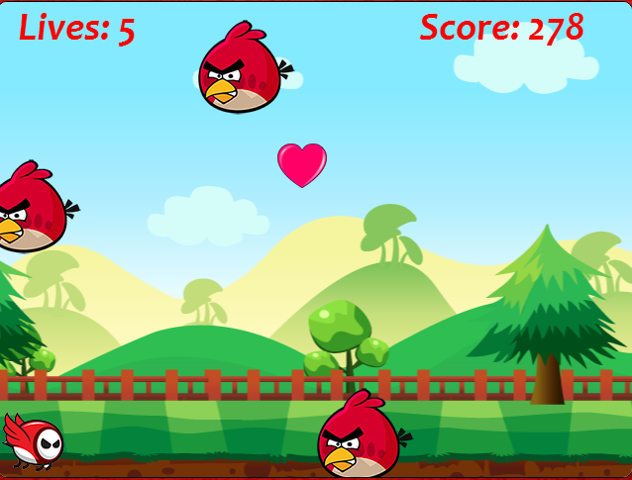

1. **Game Information**
2. **Game Description**

*The game is to avoid the enemies using the side scroller. User can*

*control the player by a mouse and the enemies will be generated randomly. Some hearts also will be generated as bonus. when user get a bonus, which will give a life.*

1. **Controls**

* *User is only allowed the control by using mouse. The player can be moved only vertically. Therefore, User can scroll in either up and down direction to avoid crazy birds and get a bonus*

1. **Interface Sketch**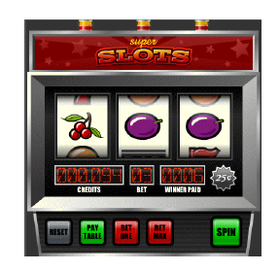
2. **Screen Descriptions**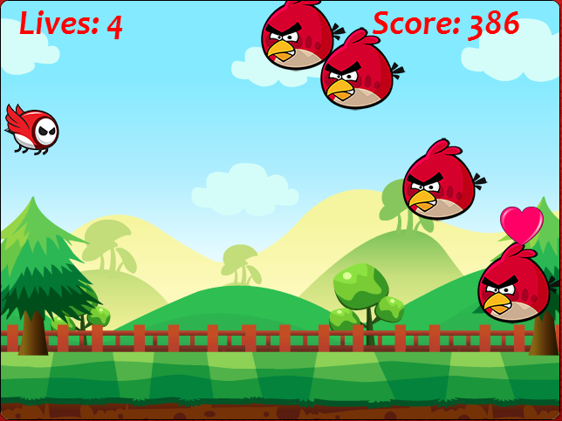

* *Forest: the background of the game*
* *Lives: number of life*
* *Score: the total of points*
* *Small bird: main character can be scrolled in either up and down direction*
* *Big bird: the enemy user has to avoid*
* *Heart: the bonus to get a life*

1. **Characters / Vehicles**

|  |  |
| --- | --- |
| **Division** | **Description** |
| **Small bird** | **Main character of the game, which can be avoided the enemy easily** |
| **Big bird** | **Each of them has randomly generated on the background** |
| **Heart** | **The bonus to give an opportunity to play the game.** |

1. **Scoring**

|  |  |
| --- | --- |
| **Combination** | **Winner paid** |
| **3 peach symbols** | **User bet * 10** |
| **3 banana symbols** | **User bet * 20** |
| **3 orange symbols** | **User bet * 30** |
| **3 plum symbols** | **User bet * 40** |
| **3 bar symbols** | **User bet * 50** |
| **3 lemon symbols** | **User bet * 75** |
| **3 seven symbols** | **User bet * 100** |
| **2 peach symbols** | **User bet * 2** |
| **2 banana symbols** | **User bet * 2** |
| **2 orange symbols** | **User bet * 3** |
| **2 plum symbols** | **User bet * 4** |
| **2 bar symbols** | **User bet * 5** |
| **2 lemon symbols** | **User bet * 10** |
| **2 seven symbols** | **User bet * 20** |
| **Jackpot** | **5000 credits** |

1. **Sound Index**

|  |  |
| --- | --- |
| **The name of sound** | **Description** |
| **Backgroundmusic.mp3** | **The main music of the game** |
| **Playing.mp3** | **The sound of player when he moves** |
| **Crush.mp3** | **The sound of crushing with enemy** |
| **Dead.mp3** | **The sound of player’s death** |
| **Enemy.mp3** | **The sound of enemy when he appears** |
| **Heart.mp3** | **The sound of clicking re-start button** |
| **GetHeart.mp3** | **The sound of getting a bonus** |
| **Chicken.mp3** | **The sound of clicking the play button** |

1. **Multimedia Index**

|  |  |  |
| --- | --- | --- |
| **Division** | **Image** | **Description** |
| **Images** |  | **Player** |
|  | **Enemy** |
|  | **Bonus** |

1. **Github Information**

*Url:* <http://gihoassign3.azurewebsites.net/>

*Git Hub:* [*https://github.com/kkh0811/Assignment3.git*](https://github.com/kkh0811/Assignment3.git)